**Ideation Phase**

**Define the Problem Statements**

|  |  |
| --- | --- |
| Date | 25 June 2025 |
| Team ID | LTVIP2025TMID59421 |
| Project Name | OrderOnTheGo: Your On-Demand Food Ordering Solution |
| Maximum Marks | 2 Marks |

**Customer Problem Statement Template:**

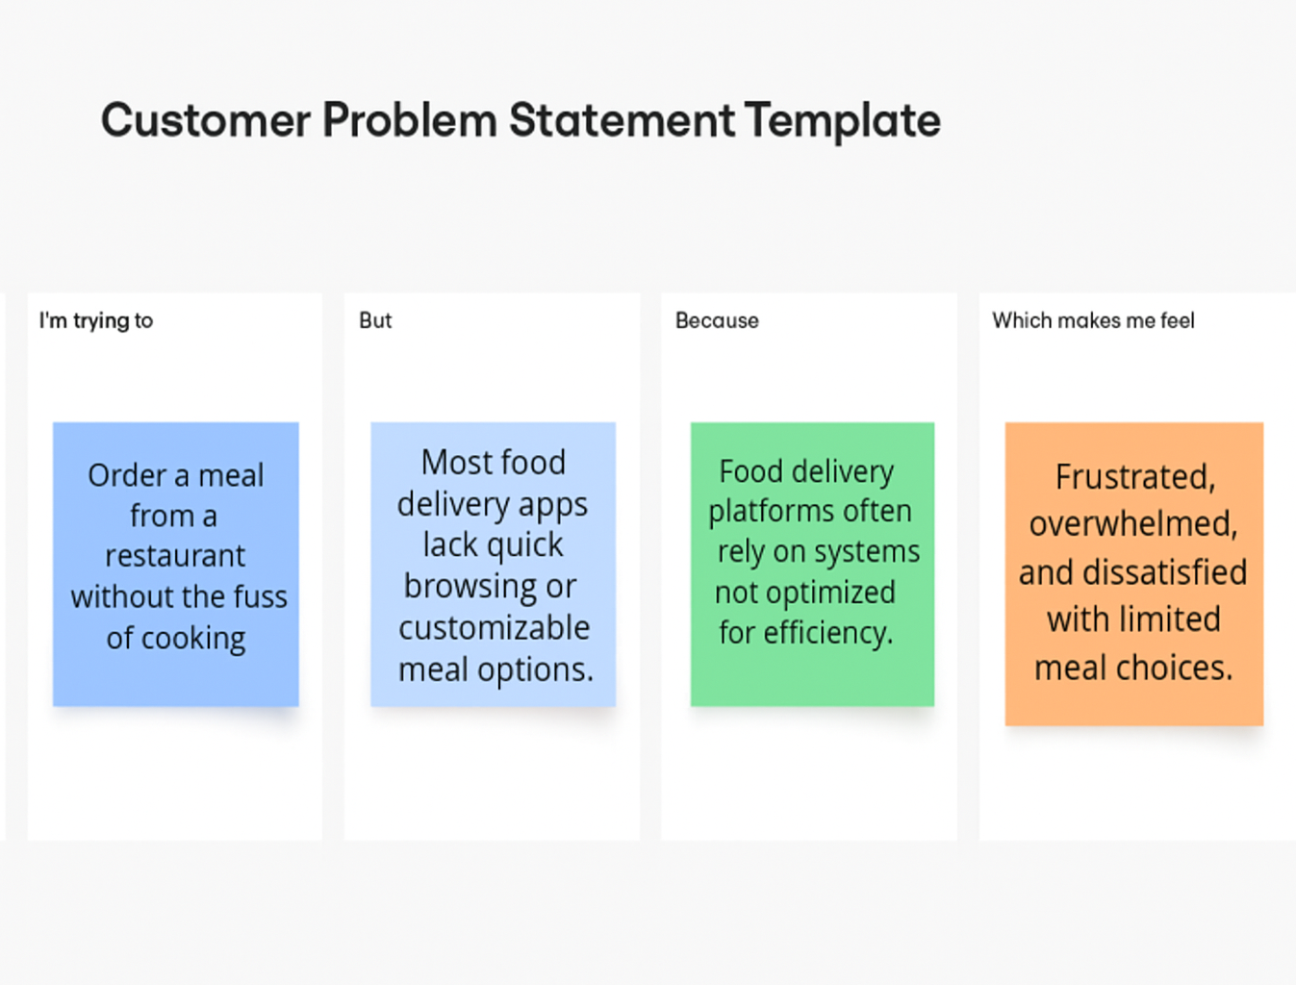To define the core problems customers face while ordering food online, and use those insights to guide the development of the Food Ordering App.

|  |  |  |  |  |  |
| --- | --- | --- | --- | --- | --- |
| **Problem Statement (PS)** | **I am (Customer)** | **I’m trying to** | **But** | **Because** | **Which makes me feel** |
| PS-1 | a working professional with a tight schedule | To order food quickly without calling restaurants or waiting long for delivery | Many restaurants don’t offer real-time menus or delivery tracking | Their systems are outdated or not integrated with online platforms | Frustrated and hungry, especially during peak hours or tight breaks |
| PS-2 | A restaurant owner managing a small team | To manage online orders efficiently and avoid missed or delayed orders | Current systems are manual or not suited for food ordering workflows | They can't afford or don’t understand complex food tech systems | Overwhelmed and underpaid despite high customer demand |